LUCAS COUNTY 911 REGIONAL
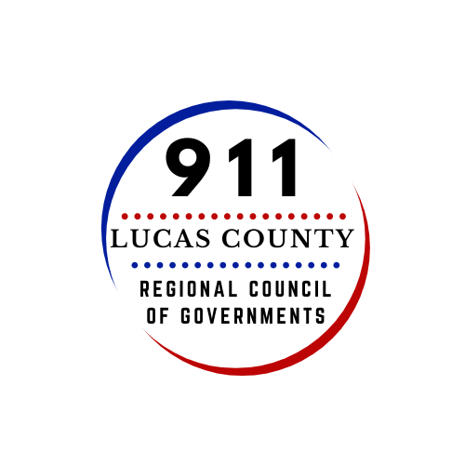
COUNCIL OF GOVERNMENTS
POSITION DESCRIPTION

Position Title: Human Resources Manager
Location: 2144 Monroe Street, Toledo, Ohio 43604
Compensation: Based upon qualification
Status: Non-Bargaining Unit, Unclassified; Exempt

DESCRIPTION
The Lucas County 911 Regional Council of Governments is a new governmental entity formed to provide merged and consolidated 911 operations in Lucas County, Ohio. The Lucas County 911 Regional Council of Governments will serve as the singular Public Safety Answering Point (PSAP) for the 441,815 residents of the 21 political subdivisions of Lucas County and provide emergency dispatch services to the County’s 13 fire departments, 15 law enforcement agencies, and countywide emergency medical service. A Board of Directors comprised of seven Lucas County public safety executives serve as the governing board. An Executive Director oversees operations and technology.
The Lucas County 911 Regional Council of Governments invites candidates with strong leadership acumen and human resources expertise to apply for this exceptional opportunity. This position reports directly to the Executive Director and provides management over the full range of human resource operations including onboarding, classification and compensation, pay and benefit administration, development and implementation of human resource policies and programs, labor/employee relations including labor, legal compliance, and other areas as assigned.
The Human Resource Manager must be energetic and possess an approachable personal style. This position is designed for an individual interested in a challenge and will require leadership, vision, strategy, and the ability to establish a culture that promotes personal growth and excellence. The Human Resources Manager functions with a high level of autonomy and responsibility.
If you get excited about making a difference, we want to hear from you.

CORE RESPONSIBILITIES
- Administers recruitment and selection processes, including development of job classifications, scoring and evaluation techniques, background checks, selection criteria and salary recommendations to attract the best candidates, consistent with industry standards and best practices.
- Collaborates with Employee Benefits Representative in the implementation, and overall management of benefits and administration, including new employee orientation, medical and dental insurance, employee wellness, and Employee Assistance Program.
- Serves as a resource to Executive Director on employment matters; provides advice, counsel, and support relative to all human resources matters.
- Develops personnel policies, procedures, manuals, agency work rules and related documents.
- Promotes and ensures compliance with employment-related federal and state laws, local ordinances, regulations and best practices.
- Develops and maintains positive and collaborative relationships with labor representatives and employee groups.
- Serves as lead negotiator for collective bargaining and participates as a key member of all labor/management issues and grievances.
- Collaborates with Training/Quality Assurance Manager to ensure staffing activities, workforce development, and certifications are performed in a manner that ensures equity, quality, and efficiency creating a culture of continuous learning and development.
- Assists supervisors and managers with discipline process, determining discipline level, writing and administering disciplines.
- Develops and manages employee recognition programs that promotes a positive work environment and employee engagement.
- Represents the Lucas County 911 Regional Council of Governments on a variety of committees related to human resources.
- Performs other work related to the human resources administration of the Lucas County 911 Regional Council of Governments as assigned by the Executive Director.

QUALIFYING EXPERIENCE AND EDUCATION
- Ten (10) years of human resource experience. Experience in the public sector is preferred.
- Five (5) years of experience working with labor unions.
- Bachelor’s degree in human resources, public administration or closely related field is strongly preferred.
- Demonstrated experience in advanced project planning and management.
- A combination of relevant experience, training, and education that provides applicant with the knowledge, skills and ability required to perform the job will be considered.
- Candidate must pass pre-employment reference and criminal history checks.
KNOWLEDGE, SKILLS AND ABILITIES
The successful candidate must be able to complete complex projects quickly and adeptly. Knowledge of contemporary principles and practices on human resource management including recruitment and selection, job classification, compensation, employee benefits and training. Knowledge and experience in collective bargaining and contract management in the public sector is essential. The position requires someone with knowledge of federal and state laws and regulations in the human resources field. Must have knowledge of effective research and record keeping methods and techniques.
Ability to apply critical thinking, problem solving and collaborative approaching to improving personnel services. Ability to strategically plan with the Executive Director for the future of 911 in Lucas County. Ability to handle interpersonal interactions with tact and diplomacy, including responding to employee complaints, or corrective action. Proven experience in driving culture improvement and change.
Considerable skill in presenting ideas clearly and persuasively, orally and in writing. Proven skill in developing job descriptions, policies and procedures, and training materials. Organizational skills to manage a variety of projects and assignments, setting business priorities is required for this position. Must have excellent skills in personal computer resources and applications. Skill in verbally communicating effectively in a variety of settings, including sensitive one on one situations and group training or presentations.

All interested applicants should email a cover letter and resume to smitchell@lc911.org with “Human Resources Manager” as the subject line. Resumes will be accepted until the position is filled.

